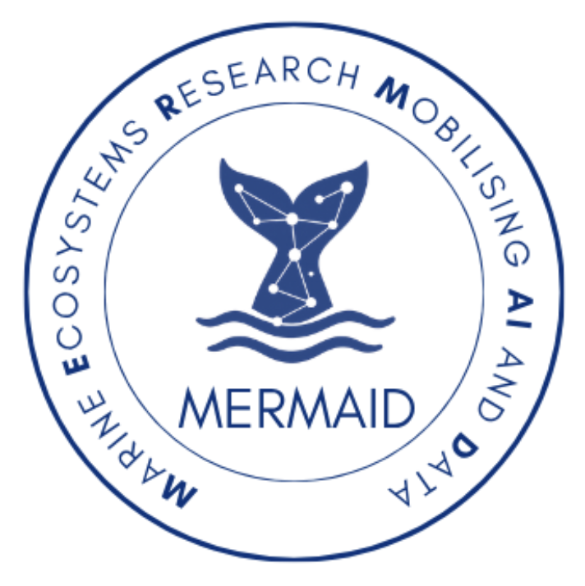

Overview
MERMAID (Marine Ecosystems Research Mobilising AI and Data) brings together experts in artificial intelligence, statistics, and marine science to transform how we understand and protect ocean ecosystems. By combining causal inference with environmental DNA (eDNA), MERMAID delivers powerful, data-driven insights into biodiversity and eco-system health.
Why It Matters
Oceans are under growing pressure from climate change, pollution, and biodiversity loss. Yet actionable insights remain limited. MERMAID enables predictive and causal understanding of marine ecosystems—supporting early warning systems, improved stewardship, and evidence-based policy.
Our Approach
MERMAID integrates satellite data, ecological records, and eDNA into a unified probabilistic framework. Using Bayesian networks and causal inference to uncover relationships between environmental drivers and biodiversity, enabling not just prediction—but explanation and intervention.

Innovation
- Causal AI for environmental systems/organisms
- Fusion of satellite, ecological, and genomic data
- Spatiotemporal ecosystem modelling
- Uncertainty-aware decision support
Impact
- Monitor marine ecosystem health
- Detect early environmental risks
- Enable targeted conservation actions
- Support global sustainability goals

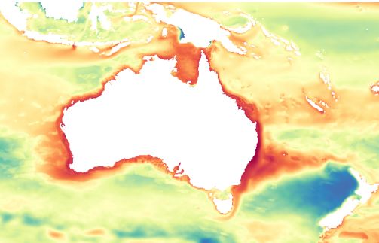

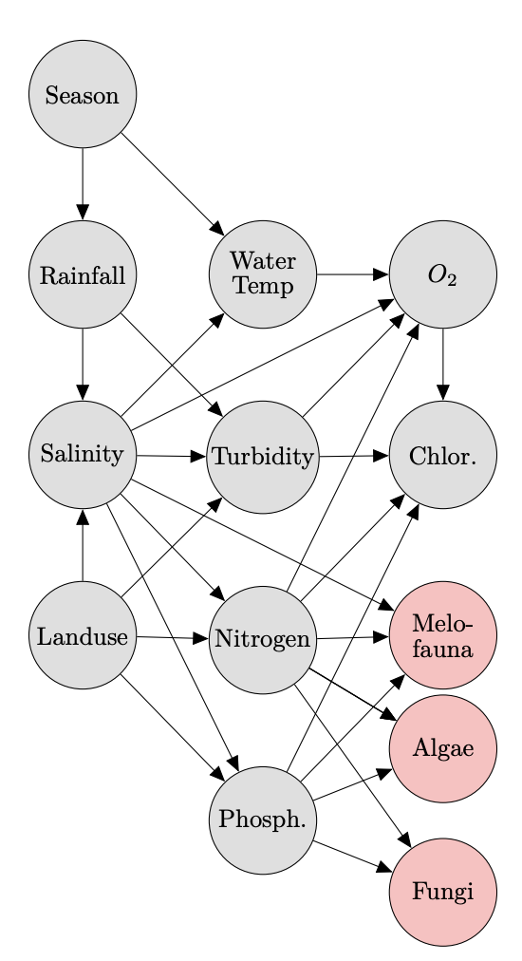

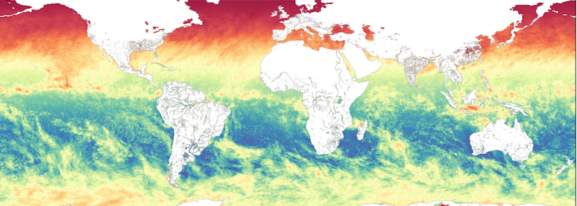

Chief investigators


Sally Cripps: Professor of Mathematics and Statistics, co-director at the Human Technology Institute (HTI).

Hadi Afshar: Associate Professor of Computer Science and Machine Learning, lead of methodological research at HTI.

Thomas Goodwin: PhD in Computational Statistics and research scientist at HTI.

Justin Seymour: Professor of Ocean Microbiology and leader of the Climate Change Cluster (C3) at UTS. Providing domain expertise and data.

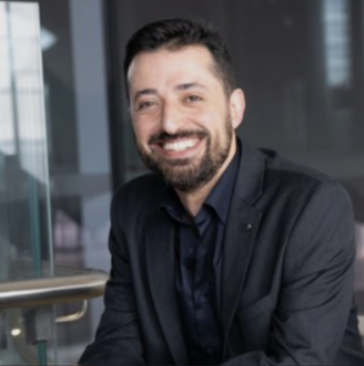
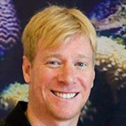
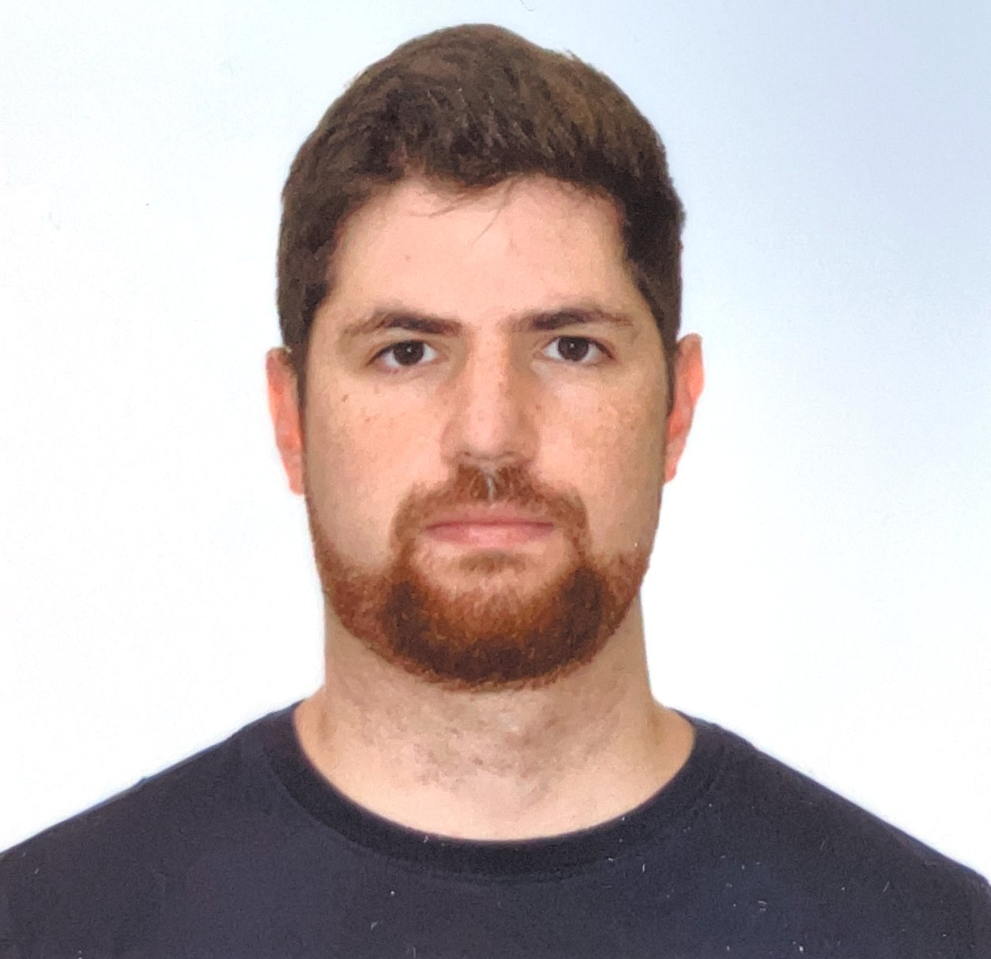

Figure reference (from left to right):
1. Photosynthetically active radiation satellite data (https://data.nasa.gov/).
2. An example of a species distribution model.
3. Bayesian network modified from:
Graham, S. E., Chariton, A. A., and Landis, W. G. (2019). Using Bayesian networks to predict risk to estuary water quality and patterns of benthic environmental DNA in Queensland. Integrated Environmental Assessment and Management, 15(1):93–111.
Funded provided by the Minderoo Foundation

