LiDA Meeting

28 April 2016

At the LiDA meeting on 28th April our group welcomed James van Rooyen as our guest speaker. James gave a most engaging account of his journey in building a flourishing online bicycle business. The venture started 8 years ago when James and his business partner had the idea of providing guided bicycle tours around the Sydney suburb of Manly.

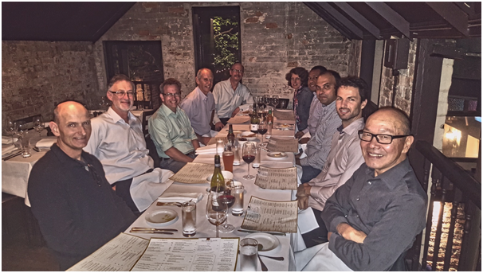
The project made a very slow and unpromising start, and James started seeking advice from some tourism industry veterans. This provided the clue that the way ahead might be bicycle hire services and not guided tours. Rapidly the business model was changed, and the enterprise started gaining traction. From their experience with re-equipping their bicycle hire fleet, the partners realised that there was an opportunity to import quality bicycles and sell direct to the public. This eliminates the middlemen with which most of their competitors are dealing, thereby providing a significant competitive advantage. The primary selling model is online, which reduces the need for investment in shop frontage and real estate. The growth in the business continues to be impressive and indicates that they have created an effective model for engaging a highly competitive market.

Throughout his talk, James showed a very clear grasp of his ability to listen and learn as he navigated his way through the challenges of building his enterprise. He spoke very candidly of the mistakes they made, and how they recognised and reversed them. He advised against seeking external funding, because it can reduce motivation and introduce complicated investor relationships. James believes that innovation is not based on a single brilliant idea, but upon successfully executing a series of good ideas that are not necessarily new. In summary, James has concentrated on creating a customer-focused business that provides great value and great service. The high regard with which his company is held within the cycling community is testament to his achievement.
The group adjourned for dinner afterwards and the animated discussions continued

