Ospitalità or HospitABLE?

Developing inclusive and sustainable employment for people with disability in the hospitality industry.
Case studies from Italy and Australia.
Introduction: Professor Carl Rhodes, Head of the Management Discipline Group

ITALY: Alex Toselli, Download Albergo Etico Project with Tracylee Arestides
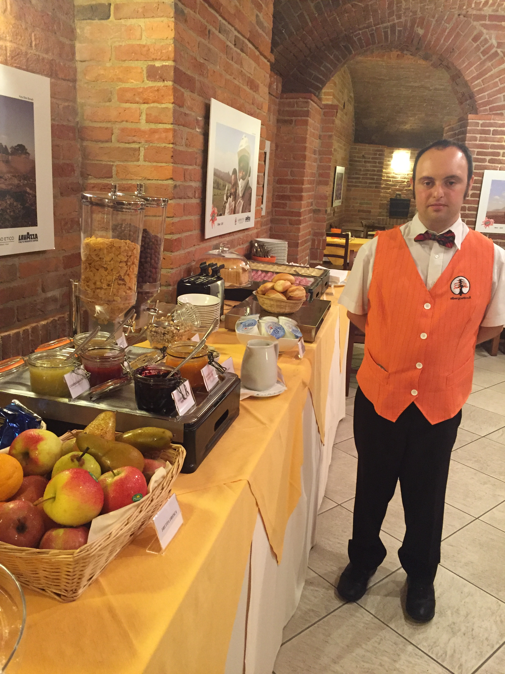
The Download Albergo Etico Project is an integrated training, life skills and employment project for people with Down syndrome in northern Italy. The Project owns and operates a hotel staffed by people with Down syndrome who train in all facets of the hospitality business. Alex Toselli, chair of the Project, will present on the business model and its social impact. ‘We see the work inclusion of people with disabilities as an extension and evolution of accessible tourism,’ says Toselli, ‘And we aim to make people with Down syndrome the real protagonists of their working life.’

AUSTRALIA: Bec Ho, Touched by Olivia – Livvi’s Cafe
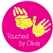
Touched by Olivia is Australia's only charity focused on the creation of inclusive communities through building playspaces. Two years ago, the next stage began with the creation of social enterprise cafes. These cafes provide employment opportunities to young people with disabilities; financial support to Touched by Olivia and activate the Livvi's Place inclusive playspaces with programs. Bec will present on the development of the overall business model of the playspaces and the development of the social enterprise Livvi’s Café http://touchedbyolivia.com.au/

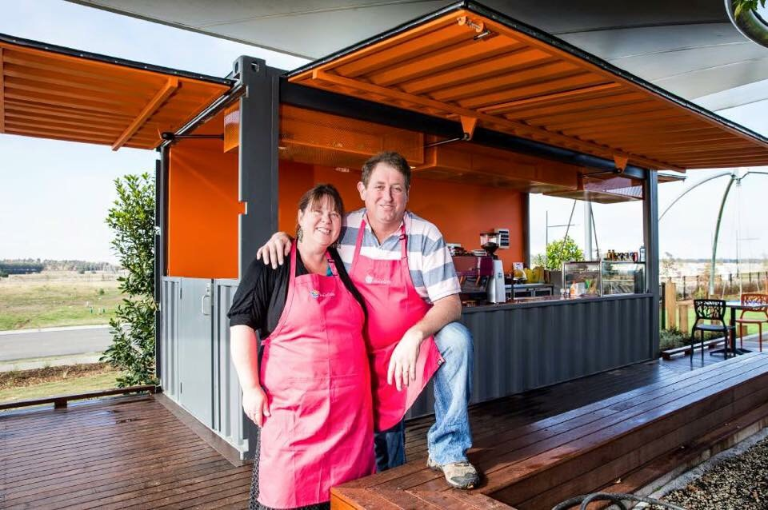

These case studies will be followed by a panel discussion, chaired by
Prof Simon Darcy, Professor of Social Inclusion, UTS School of Business
The afternoon will conclude with drinks, nibbles and networking opportunities.

Thursday 17 November 2016
3 - 5:30pm
Level 8, Room 002
Dr Chau Chak Wing Building
14 Ultimo Road, Ultimo
Registration
CLICK HERE to register or visit https://www.eventbrite.com.au/e/ospitalita-or-hospitable-tickets-28715107660
Registrations close Tuesday,
15 November 2016

