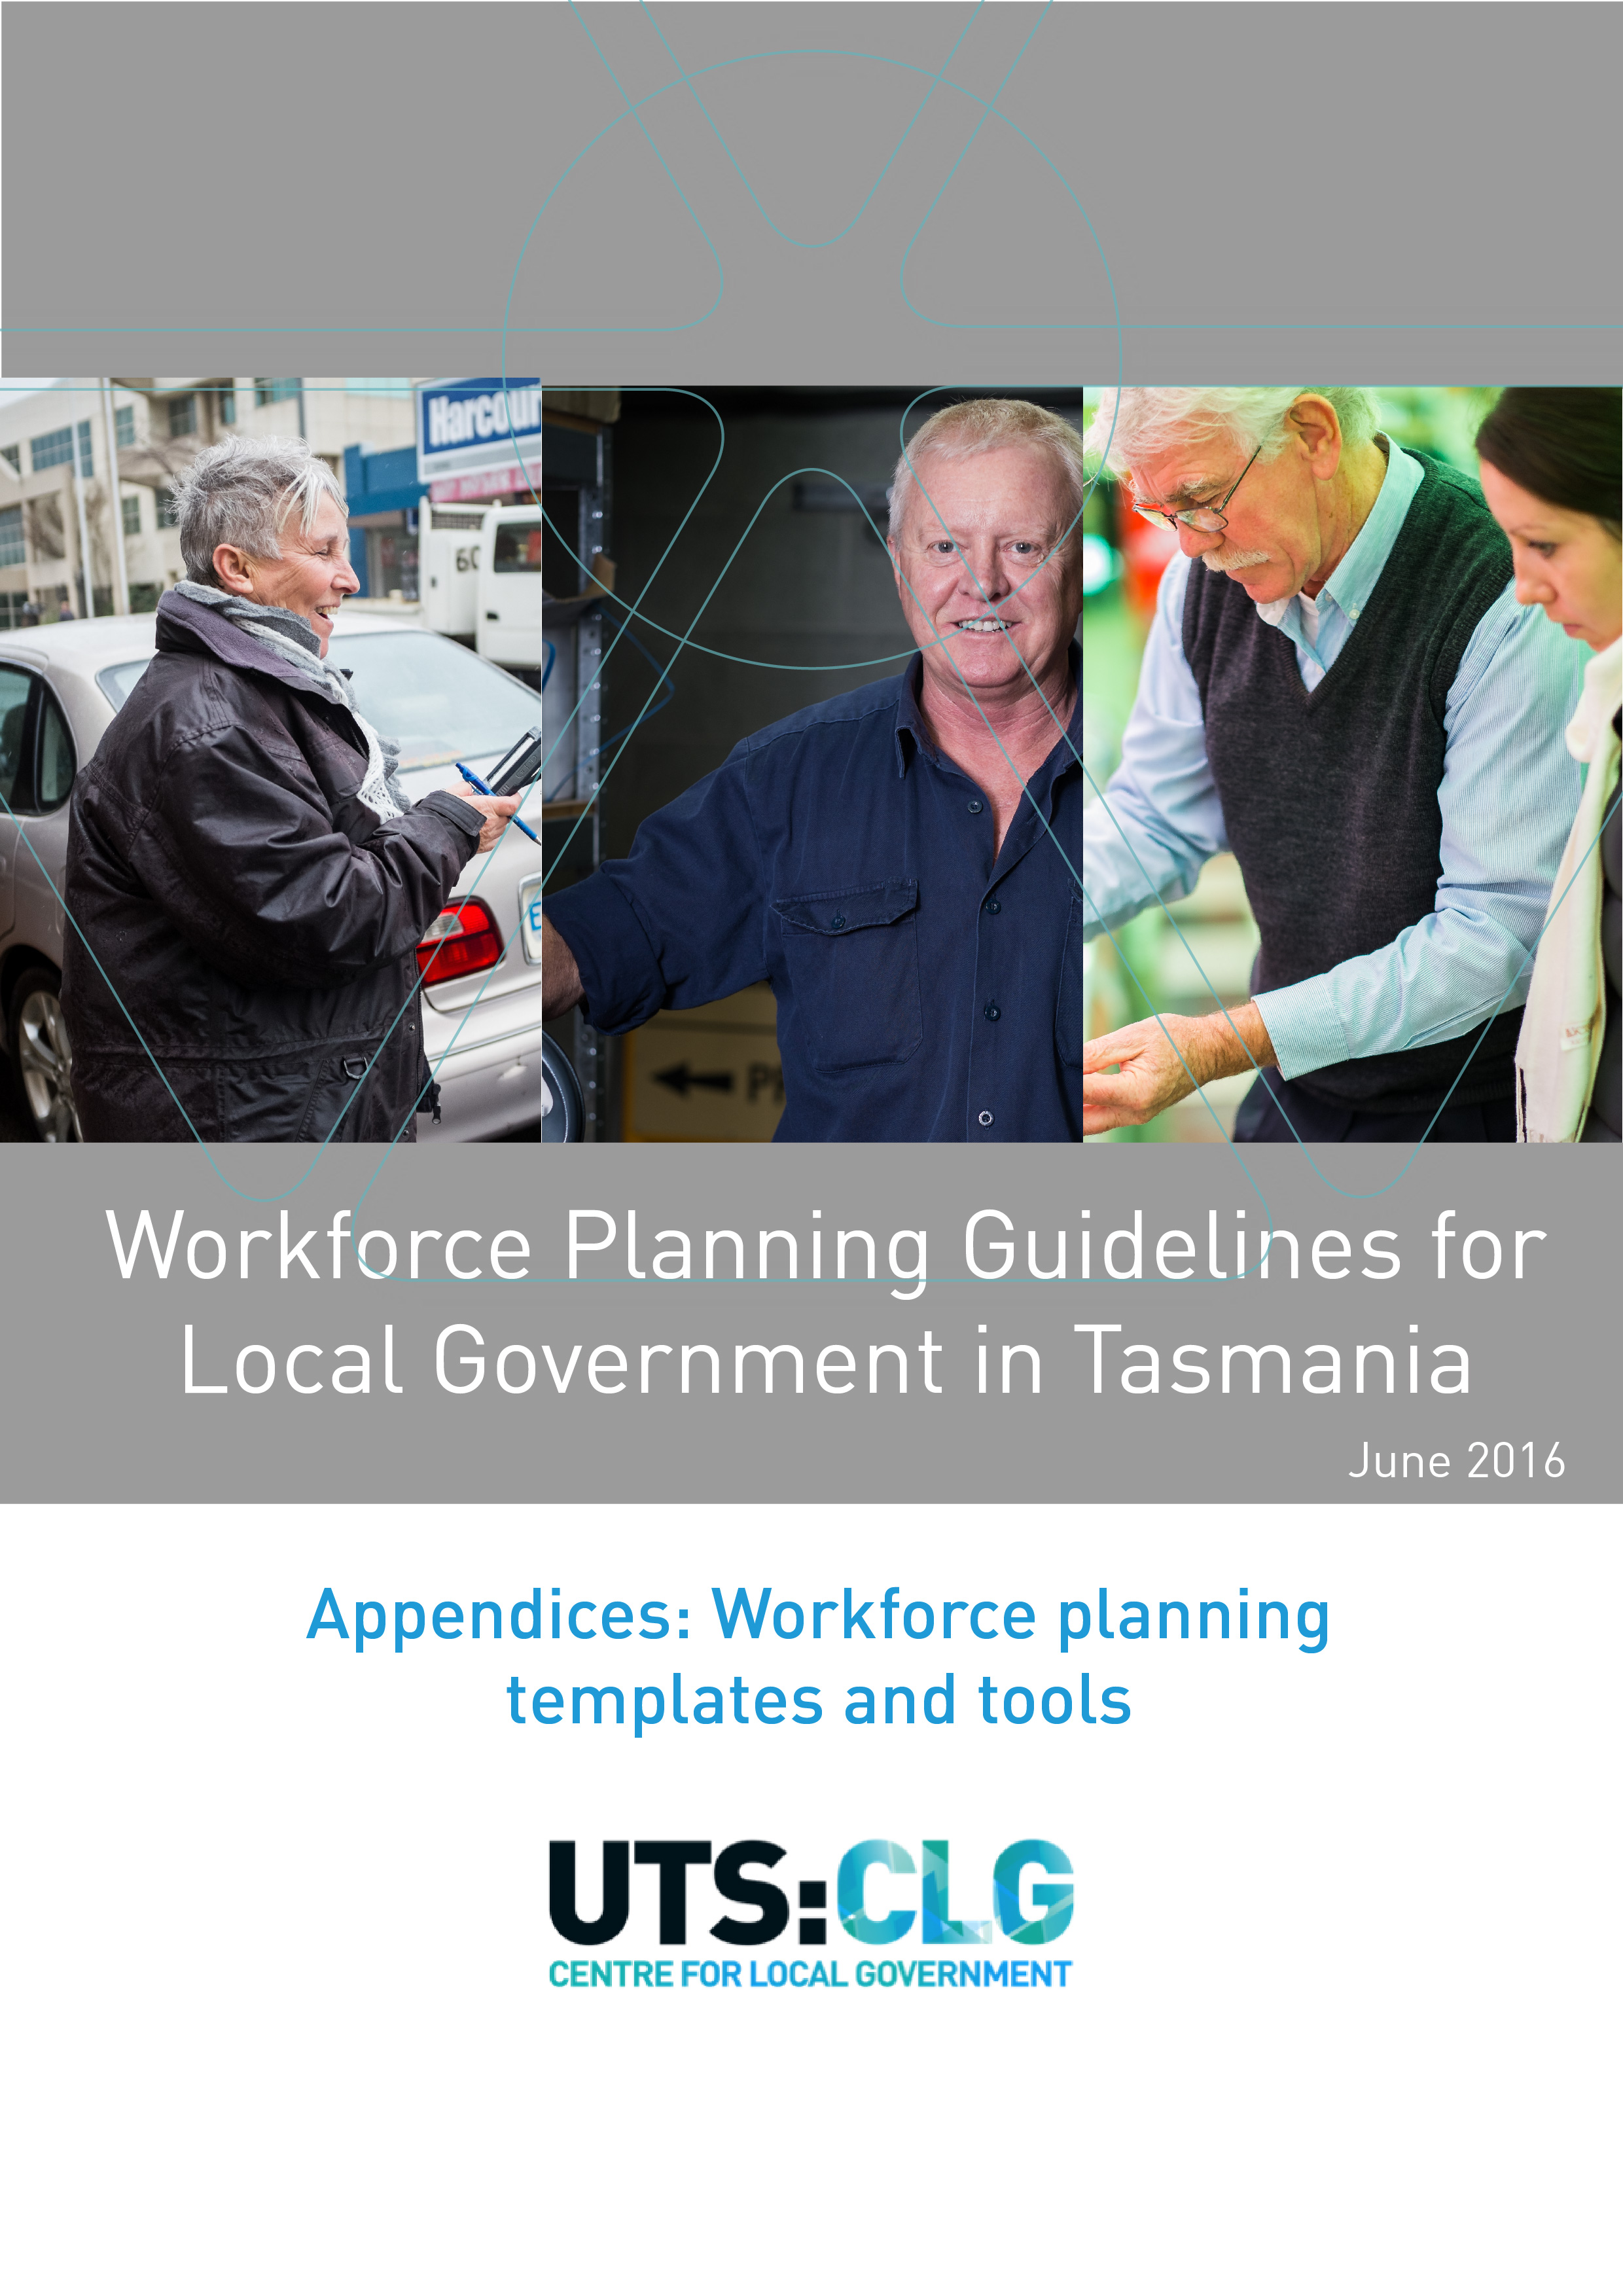

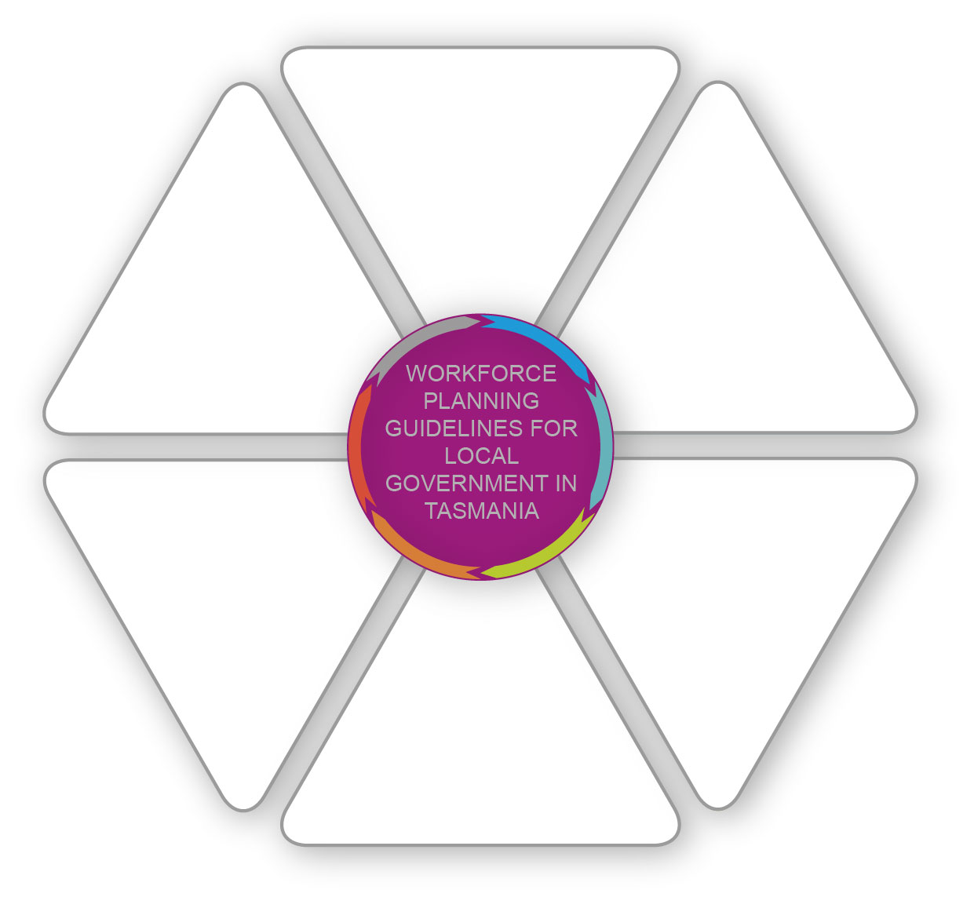
Foreword
Workforce planning in Tasmania as a whole, and in the local government sector in particular, is essential to meet the needs of communities and deliver a growing, prosperous Tasmania. As the level of government best placed to meet community needs, councils are in a unique position to identify the skills, knowledge and expertise needed to effectively tailor services, generate economic and employment opportunities and support the overall prosperity of their local and regional communities.
Planning a future workforce to deliver vital services needs to be clearly linked to local, regional and state-wide priorities. Councils have a key role to plan for their own workforces as part of strategic planning but also play an important role in partnering with a range of local, regional and state level organisations to identify and support conditions for economic growth.
Workforce planning brings important benefits to councils and their communities and these guidelines are intended to help local government plan at a local, sub-regional and regional level to support the future growth of a vibrant Tasmanian economy.

Acknowledgements
These guidelines were written by SallyAnn Hunting and Roberta Ryan at the University of Technology Sydney, Centre for Local Government as part of a project to improve Tasmanian local government understanding of the benefits of workforce planning and build capacity to enable better workforce planning.
The project was funded by a grant from Skills Tasmania (Tasmanian Department of State Growth) and developed in partnership with the Local Government Association of Tasmania and Burnie, Circular Head and Waratah-Wynyard Councils.
In addition, the following councils formed the Reference Group to help shape and tailor the guidelines to the unique context in Tasmania:
- Break O’Day Council
- Burnie Council
- Circular Head Council
- Glamorgan Spring Bay Council
- Hobart City Council
- Kingborough Council
- Waratah-Wynyard Council.

Citing this report
Hunting, S.A. & Ryan, R. 2016. Workforce planning guidelines for local government in Tasmania. University of Technology Sydney, Centre for Local Government.
© University of Technology Sydney: Centre for Local Government, 2016
UTS CRICOS Provider Code: 00099F

List of templates and tools
  - Templates and tools
Appendix A. Workforce plan template 1
Appendix B. Stakeholder identification template 9
Appendix C. Mapping stakeholder level of interest and influence 10
Appendix D. PESTLE framework 11
Appendix E. Strategic plans and service provision 13
Appendix F. Workforce analysis 14
Appendix G. Critical roles 16
Appendix H. Potential future scenarios 17
Appendix I. Gap analysis 19
Appendix J. Action list 21
Appendix K. Implementation plan 22
Appendix L. Other resources 23

- Workforce plan template

Workforce Plan for [Insert name of local government(s), regional authority, region, state etc.]

[Add logo and/or pictures]

[Insert month and year of preparation]

  - Contents for workforce plan
1 Overview 3
1.1 Scope and scale of the workforce plan 3
1.2 Allocate resources 3
1.3 Alignment with other plans 3
1.4 Key stakeholders 3
1.5 Data and information sources 3
1.6 Inter- and intra-organisational commitment 3
1.7 The project plan 3
2 Where are we now? 4
2.1 The current external context 4
2.2 Strategic documents and service provision 4
2.3 The current workforce 4
2.3.1 Data sources 4
2.3.2 Workforce analysis 4
2.3.3 Critical roles 4
2.4 Overall summary 4
3 Where might we be in the future? 5
3.1 The forecast external context 5
3.2 Future demand for services 5
3.3 Workforce needed to meet demand 5
3.4 Overall summary 5
4 Where are the gaps? 6
4.1 The gaps 6
4.1.1 Numbers and roles 6
4.1.2 Skills 6
4.1.3 Profile 6
4.2 The risk of not addressing the gaps 6
4.3 Priorities 6
4.4 Overall summary 6
5 Strategies to address the gaps 7
5.1 Strategies and actions to address the gaps 7
5.2 The costs/benefits of actions 7
5.3 Partnerships for success 7
5.4 Implementation plan 7
6 Monitoring and evaluation 8
6.1 Evaluation of the drafting process 8
6.2 Timeframe for monitoring 8
6.3 Evaluation of the success of the workforce plan 8
6.4 Opportunities to share learnings 8

Overview

This section is a high level overview about the aims of the workforce plan and expected outcomes. It should also include the following sections:

Scope and scale of the workforce plan
This section details the scope and scale of the workforce plan and reasons for this selection.

Allocate resources
This section details the resources which will be used to carry out the workforce planning process.

Alignment with other plans
This section details how the workforce plan will align with other strategic and operational plans.

Key stakeholders
This details the key stakeholders which will be needed to successfully develop and implement the workforce plan.

Data and information sources
This section details the data and information used to build an evidence base to inform the workforce plan.

Inter- and intra-organisational commitment
This section details how commitment has been built within and across organisation as needed.

The project plan
This section outlines the timeline for the development of the workforce plan, resourcing, key deliverables and the governance process.

Where are we now?

The current external context
This section identifies the current contextual issues which impact on workforce planning such as:
- Current national context
- Current Tasmanian context
- Current regional context.

Strategic documents and service provision
This section identifies where the successful implementation of strategic goals and service provision is dependent on workforce planning.

The current workforce
This section analyses the current workforce to highlight key issues which will impact on capacity to delivery on strategies and services.

Data sources
This section details the sources of data and information used.

Workforce analysis
This section analyses the current workforce to understand the components of the workforce to identify key trends and issues.

Critical roles
This section identifies those roles which are critical to achieving strategic and operational outcomes at state, regional or local scales.

Overall summary
This section pulls together the information gathered into a summary section with graphs and tables which presents the narrative and analysis of the current situation.

Where might we be in the future?

The forecast external context
This section analyses what the external environment might look like in the future.

Future demand for services
This section examines what impact any changes in the external environment might have on service delivery in terms of services and levels of services.

Workforce needed to meet demand
This section analyses the impact of Sections 3.1 and 3.2 on staff needed in the future, taking into account the scenario analysis.

Overall summary
This section pulls together the information gathered into a summary section and provides an overall picture of workforce needs in the future over one, three, five and ten year time frames.

Where are the gaps?

The gaps
This section brings together all of the knowledge so far to identify the gaps.

Numbers and roles
This section identifies the gaps in terms of numbers of roles.

Skills
This section identifies the gaps in terms of skills.

Profile
This section identifies the gaps in terms of profile.

The risk of not addressing the gaps
This section identifies the risk to organisational strategy based on the likelihood and consequence of not filling the gaps.

Priorities
This section details the priority gaps to address depending on a range of criteria, including risk.

Overall summary
This section is a high level summary of all the gaps and their relative priorities.

Strategies to address the gaps

Strategies and actions to address the gaps
This section provides a detailed summary of the strategies and actions plus associated responsibilities, budget and performance measures.

The costs/benefits of actions
This section identifies the relative costs/benefits of the potential actions in order to assess various scenarios for change and the impact on financial sustainability.

Partnerships for success
This section highlights the need to create collaborative partnerships and networks for success, regardless of the scale of the workforce plan.

Implementation plan
This section pulls together the prioritised actions into a plan for implementation. It identifies actions for change, responsibilities for implementation, resource required and expected outcomes.

Monitoring and evaluation

Evaluation of the drafting process
This section details how appropriate and effective the drafting process was.

Timeframe for monitoring
This section identifies the timeframe and responsibility for monitoring the workforce plan in order to identify and respond to any changes which affect the underlying assumptions in the workforce plan.

Evaluation of the success of the workforce plan
This section describes how the outcomes from the workforce plan will be evaluated to assess whether the aims of the workforce plan have been achieved.

Opportunities to share learnings
This section documents how learnings and reflections from the workforce planning process will be shared to build sector knowledge and capacity for the future.

- Stakeholder identification template
This framework helps to identify key stakeholders for workforce planning and the level of engagement needed. Use the template at Appendix C to map the level of interest and influence which then drives the level of engagement.
Stakeholder | Internal/external | Role | Level of interest  H/M/L |  | Level of influence  H/M/L | Level of engagement i.e.  inform, consult, involved, collaborate, empower

- Mapping stakeholder level of interest and influence
This framework helps understand what the relative levels of interest and influence are for each stakeholder. Depending on where they sit within the matrix, stakeholders will need to be engaged differently.

COLLABORATE/EMPOWER
- High degree of influence and also of high importance for success
- Construct good working relationships to ensure an effective coalition of support

ENGAGE/MANAGE CLOSELY

LOW
HIGH
LOW
HIGH
LEVEL OF INTEREST
LEVEL OF INFLUENCE
INVOLVE/CONSULT
- High influence and can affect outcomes but whose interests are not necessarily aligned
- May be a source of significant risk and require careful monitoring and management
KEEP SATISFIED
CONSULT
- High importance to the success of service delivery but with low influence
- Their interests need to be protected

KEEP INFORMED

INVOLVE/CONSULT
- Low influence on or importance service delivery
- Require limited monitoring or evaluation but are of low priority

MONITOR – MINIMUM EFFORT

- PESTLE framework
This framework helps to identify influencers in the current external current context. Complete the framework and then identify the key factors in the Workforce Plan.
Factor | Level
 | National | State | Regional | Local
Political
- Social policies
- Government spend
Economic
- Growth policies
- Infrastructure policies
- Unemployment rates
Social
- Demographics e.g. ageing population
- Education levels
- Lifestyle trends
Technology
- New back end technology
- Customer service technology
- NBN
- Impact on work from home
Legal
- Changes to legislation e.g. planning laws
- Employment conditions
- Health and safety
- Risk management
Environmental
- Impact of climate change
- Environmental health
- Waste disposal
- Tourism
- Competition for skilled workforce
- Strategic plans and service provision
This framework helps identify where various strategic planning documents identify particular workforce requirements to exist in order for their objectives to be realised.
Relevant strategic planning document | Key goals/objectives | Outcomes dependent on workforce | Implications for workforce to deliver outcomes e.g. number, skills, specialist training

This framework helps identify where community needs for services and service levels are not being met and where they are dependent on changes to workforce.
Service | Service level | Community satisfaction with service or service level | Implications for workforce to improve service quality

- Workforce analysis
This framework helps identify issues and trends in the workforce. Depending on the scale, benchmarking between other organisations can be useful where there is direct comparability of roles and responsibilities (and the data is available).
See Section 2.3.1 for potential sources of data
Element | Question to ask | Data
Number and organisation | - How many individuals and full-time equivalents exist?  - What are their roles?  - How as this changed over time?  - Where are staff located?  - What is the health of our organisation in terms of morale and culture? | - Number of people, including headcount and full-time equivalent and their roles  - Staff location  - Number of short-term staff, including temporary, casual and contractors
Profile | - What is the average age (overall and by type of role)?  - What is the most frequent age group?  - What is the gender/diversity split by role?  - Is this split a good balance?  - Does the split reflect the spatial community?  - What is the salary band split?  - When do people leave i.e. retire or resign?  - What is the average tenure? Is this too high or too low?  - What is the split of employment status by department?  - Does age or tenure prose a risk? | - Age  - Gender  - Diversity including ability, cultural etc.  - Length of service  - Grades/salary bands, classifications including apprentice/trainee  - Recruitment and retention rates  - Turnover including, retirements and resignations  - Employment status (full and part time) including permanent, temporary, contractor, consultancy etc.
Capacity and capability | - What are the levels of contract v FTE hours?  - What other sources are used to meet business needs e.g. consultants, resource sharing  - What are the levels of attendance and sick leave/carer leave?  - Is leave too high in some areas?  - Are there significant levels of accrued holidays?  - What are the key strengths?  - What known skills gaps exist? | - Hours worked  - Sick leave/carer leave  - Accrued holidays  - Skills levels and known skills gaps
Critical roles  (See also Appendix G) | - What are the critical roles?  - Does a plan exist to ensure the risk of them not being filled is mitigated? | - Roles with long vacancy periods or high turnover  - Roles operating under shared services model due to skills shortages  - Known skills shortages

- Critical roles
This framework helps identify those roles which are critical and is especially useful for smaller local governments who may not have the resources to complete a full-blown workforce plan.
Role | Mission critical | Hard to fill |  | Known skills shortage
 |  | Long vacancy | Unattractive role | Not available at the right scale | Highly specialist skills | Long lead time to train

- Potential future scenarios
This framework helps identify potential future scenarios based on a combination of the forecast external context and possible future demand for services. Complete a few frameworks and assess which one is the most likely.
Scenario 1: [Title]
Description
Timeframe
Likelihood
Workforce demand implications | Capacity  (size, structure)
Capability
(skills, capabilities)
 | Cost (FTE)
Workforce supply implications | Capacity  (size, structure)
Capability
(skills, capabilities)
Key risk
Mitigation strategies

Scenario 2: [Title]
Description
Timeframe
Likelihood
Workforce demand implications | Capacity  (size, structure)
Capability
(skills, capabilities)
 | Cost (FTE)
Workforce supply implications | Capacity  (size, structure)
Capability
(skills, capabilities)
Key risk
Mitigation strategies

- Gap analysis
Table 1: Numbers and roles gaps
This framework helps identify current FTEs, and the current gaps and future gaps over longer timeframes. Adapt the framework to suit your own timeframe.
Job title | Critical role Y/N? | Location | Employment status | Current supply  FTE | Current demand FTE | Current gap  FTE | Future demand FTE |  |  |  | Future gap  FTE
 |  |  |  |  |  |  | Year 1 | Year 3 | Year 5 | Year 10 | Year 1 | Year 3 | Year 5 | Year 10

Table 2: Skills gaps
This framework helps identify skills gaps which need to be sourced or where staff can be upskilled.
Job title | Forecast skill deficit
 | Year 1 | Year 3 | Year 5 | Year 10

Table 3: Profile gaps
This framework helps identify profile gaps which need to addressed.
Issue | Changes to workforce profile needed
 | Year 1 | Year 3 | Year 5 | Year 10

- Action list
The framework takes the priority gaps and outlines an action list to address the gaps.
Gap | Risk | Priority  1,2,3 etc. | Strategy | Action | Cost/  benefit | Key partners | Responsibility | Timeframe | Budget

- Implementation plan

Gap | Actions required | Objective of action | Responsibility for change | Cost/resources required | Expected outcome | Evaluation of change (Performance indictors/targets

- Other resources
Local government workforce data
Australian Centre of Excellence for Local Government 2015. Profile of the Australian local government workforce 2015.
Available at: opus.lib.uts.edu.au/handle/10453/42142
Australian Centre of Excellence for Local Government 2013. Future-proofing Local government: National Workforce Strategy 2013-2020. Available at: opus.lib.uts.edu.au/handle/10453/42140
Other local government workforce planning guides
NSW Government Premier’s Department 2003. Workforce Planning: A guide. Available at: www.dpc.nsw.gov.au/__data/assets/pdf_file/0017/12680/WorkforcePlanningAGuide.pdf
State Services Authority Victoria 2006. Workforce Planning Toolkit: guide for workforce planning in small to medium sized Victorian public sector organisations. Available at: vpsc.vic.gov.au/wp-content/uploads/2015/02/5601_616_WFPToolkitReport1.pdf
Other workforce planning guides
Government of South Australia 2012. Employer resource Kit: A guide to workforce planning and development. Available at: www.skills.sa.gov.au/DesktopModules/Bring2mind/DMX/Download.aspx?Command=Core_Download&EntryId=1819&PortalId=6&TabId=1936
Standing Council on Tertiary Education, Skills & Employment (SCOTESE) 2013. National regional workforce planning and development report. Available at: www.skills.tas.gov.au/__data/assets/pdf_file/0020/130457/National_Regional_Workforce_Planning_and_Development_Report.pdf
State Services Authority Victoria 2006. Workforce Planning Toolkit: guide for workforce planning in small to medium sized Victorian public sector organisations. Available at: vpsc.vic.gov.au/wp-content/uploads/2015/02/5601_616_WFPToolkitReport1.pdf
Tasmanian Government Department of Economic Development, Tourism and the Arts Better workplaces: Employer resource kit. Available at: www.skills.tas.gov.au/employersindustry/industryresources/workforce-planning-and-development-resources/Better_Workplaces.pdf

